Dear Student:
THANK YOU for taking the time out to complete the Fuel the City Scholarship and Award. You have just initiated the first step in being the hero your neighborhood needs and deserves. We hope that through your hard work and determination, you can prove to be a Hero that your community foundation wants to recognize and encourage to continue your educational effort.
The Neighborhood Heroes Foundation will be presenting the Fuel the City Scholarship to a select few high school students graduating in the DFW Metroplex. As well as partnering with DAExDAE and Champs Sports to gear you up as our recipient of the 2022 Fuel the City Award, equipping you for the road ahead.
The 2022 Fuel the City Scholarship is an Academic Merit Scholar Award. This scholarship will support five graduating students in the DFW Metroplex by providing them $1,000 each for their educational expenses and endeavors.
For you to claim this award and scholarship, please submit the application form provided on the following page.
If you have any questions or concerns, please feel free to contact us by phone or via email.
THANK YOU again on for taking the initiative for this award.
Sincerely Your Neighborhood Heroes,
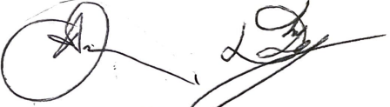
Ajayne Bunton & Devan Legington
DaeXDae LLC
The Neighborhood Heroes Foundation
Email: neighborhoodheroesllc@gmail.com
Phone: 469.967.1652
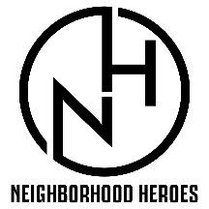
Fuel the City Award/Scholarship Application

(Please print)

Student Full Name: _______________________________________________________
Date of Birth: _______/________/_______
High School Name: ______________________ Student Email: _____________________________
Phone #: __________________ Parent Email: _____________ Parents phone number: ______
Current Cumulative GPA: _____________
List any ACADEMIC awards, honors, or achievements you have received during high school:
_____________________________________________________________________________________
_____________________________________________________________________________________
List any sports you play currently or have played during your time in high school:
_____________________________________________________________________________________
_____________________________________________________________________________________
List any hobbies or interests you have outside of school and sports: ___________________________________________
_____________________________________________________________________________________
List any volunteer activities in the community during high school:
_____________________________________________________________________________________
_____________________________________________________________________________________
List the colleges where you are applying for admission (if you have already committed to a school, please note): _____________________________________________________________________________________
Attach a brief typed or written essay of your goals or why you believe you are a good candidate (there is no length, it is an open-ended response) for this application.
Deadline for submission to your school is May 31st, 2023.

